**“MOBILE SIGNAL JAMMER”**

**PROJECT REPORT**

Submitted for the course:

**ANALOG ELECTRONIC CIRCUITS**

**By-**

**ADHEIK DOMINIC(16BEC0620)**

**RAKESH JHA(16BEC0554)**

**JANARDHAN G(16BEC0192)**

**RAVIKANTH Y(16BEC0800)**

Slot: L3+L4

**Submitted to :**

Prof. AARTHI.G

(School Of Electronics And Communication Engineering)



October,2018

**CERTIFICATE**

This is to certify that the project work entitled **“**MOBILE SIGNAL JAMMER” that is being submitted by “ADHEIK DOMINIC,RAKESH, JHAJANARDHAN.G,RAVIKANTH.Y” for Analog electronic circuits is a record of bonafide work done under my supervision. The contents of this project work, in full or in part, have neither been taken from any other source nor have been submitted for any other CAL course.

Place: Vellore

Date: October, 2018

Signature of Students: Signature of Faculty:

ADHEIK DOMINIC Prof. AARTHI.G

16BEC0620

RAKESH JHA

16BEC0554

JANARDHAN G

16BEC0192

RAVIKANTH Y

16BEC0800

**ACKNOWLEDGEMENTS**

Every project is successful largely due to the effort of a number of people who have always given their valuable advice or lend a helping hand. We sincerely appreciate the inspiration, support and guidance of all those people who have been instrumental in making this project a success.

We, students of **Vellore Institute of Technology**, belonging to the SENSE School, Electronics and Communication (ECE) Branch, are extremely grateful to all of them who helped a great deal and gave their contribution in completing this project.

We express our gratitude to the Management and our **School Dean** for giving us an opportunity for carrying out our studies related to the project at the University.

At this juncture I feel deeply honoured in expressing my sincere thanks to **Prof. Aarthi.G** for making the resources available at right time and providing valuable insights leading to the successful completion of our project.

I would also like to thank all the faculty members of **Vellore Institute of Technology** for their critical advice and guidance without which this project would not have been possible.

Last but not the least I place a deep sense of gratitude to our family members and our friends who have been constant source of inspiration during the preparation of this project work.

**Introduction:**

CELL PHONE JAMMER IS AN ELECTRONIC DEVICE THAT BLOCKS TRANSMISSION OF SIGNALS BETWEEN A CELL PHONE AND A BASE STATION. BY USING THE SAME FREQUENCY AS A MOBILE HANDSET, THE CELL PHONE JAMMER CREATES STRONG INTERFERENCE FOR COMMUNICATION BETWEEN THE CALLER AND RECEIVER. IT IS EFFICIENT IN BLOCKING TRANSMISSION OF SIGNALS FROM NETWORKS INCLUDING UMTS, 3G, CDMA, GSM AND PHS.

MOBILE PHONES OPERATE AT DIFFERENT FREQUENCY BANDS IN DIFFERENT COUNTRIES. FOR CANADA THE 1900 MHZ BAND IS THE PRIMARY BAND, PARTICULARLY FOR URBAN AREAS. 850 MHZ IS USED AS A BACKUP IN RURAL AREAS. USA USES 850 AND 1900 MHZ BANDS, DEPENDING ON THE AREA. EUROPEANS TEND TO USE THE GSM 900 AND 1800 BANDS AS STANDARD. MIDDLE EAST, AFRICA, ASIA AND OCEANIA ALSO USE THESE FREQUENCY BANDS. IN RUSSIA AND SOME OTHER COUNTRIES, LOCAL CARRIERS HAVE LICENSES FOR 450 MHZ FREQUENCY TO PROVIDE CDMA COVERAGE.

THE USE OF DIFFERENT FREQUENCIES MAKES IT DIFFICULT TO HAVE A JAMMER FOR ALL FREQUENCIES. HOWEVER THE BELOW MENTIONED FORMULA CAN BE USED TO CALCULATE THE REQUIRED VALUES.

F= 1/ (2*PI*SQRT (L1*C1))

DEPENDING ON THE FREQUENCIES YOU NEED TO BLOCK, THE VALUES OF INDUCTOR (L1) AND CAPACITOR (C1) CAN BE ALTERED.

FOR EXAMPLE, IF MOBILE PHONES AT YOUR AREA WORK AT 450 MHZ, YOU NEED TO GENERATE 450 MHZ WITH SOME NOISE TO ACT AS THE BLOCKING SIGNAL. NOW THE CELL PHONE RECEIVER WILL NOT BE ABLE TO UNDERSTAND, WHICH SIGNAL TO RECEIVE. WE HAVE SUCCESSFULLY BLOCKED CELL PHONE SIGNALS.

**Aim and Objective**

* THE AIM OF THE PROJECT IS TO BLOCKS TRANSMISSION OF SIGNALS BETWEEN A CELL PHONE AND A BASE STATION BY USING THE SAME FREQUENCY AS A MOBILE HANDSET

**Theory**

**Principal Component Analysis**

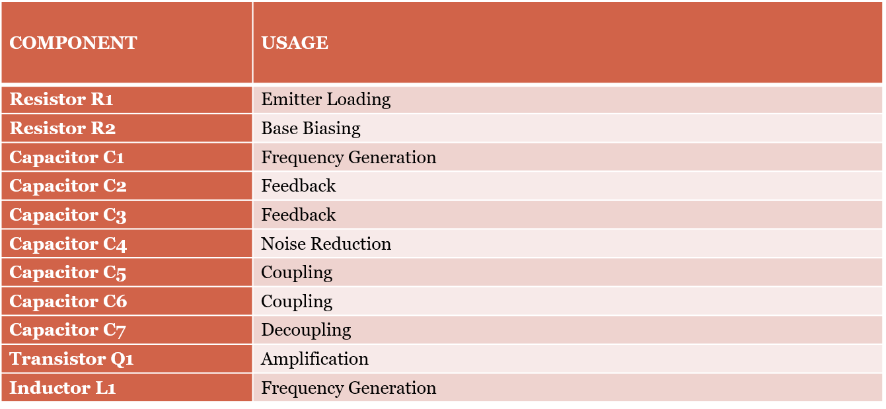

**CIRCUIT DIAGRAM**

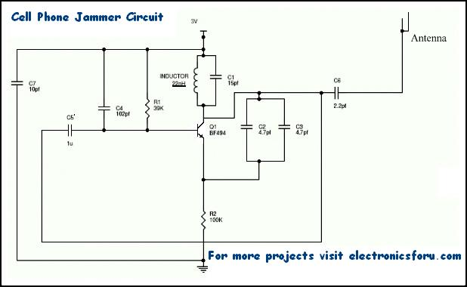

**RANGE & FREQUENCY**

MOST JAMMERS ONLY HAVE A RANGE OF ABOUT 50 TO 80 FEET AND WILL ONLY EFFECTIVELY JAM YOUR IMMEDIATE SURROUNDINGS. MOBILE BLABBERMOUTHS WILL JUST THINK THEY'VE HIT A DEAD SPOT IN THEIR CELL PHONE COMPANY'S COVERAGE UNTIL THEY LEAVE YOUR JAMMERS IMMEDIATE VICINITY. STRONGER JAMMERS ARE AVAILABLE TO COVER LARGER STRUCTURES LIKE OFFICE BUILDINGS, MOVIE THEATERS AND CHURCHES. THEY LOOK LIKE A MISCELLANEOUS METAL BOXES WITH WIRES STICKING OUT AND ARE USUALLY MOUNTED ON WALLS OR CEILINGS (SEE IMAGE ON RIGHT).

MOST CELL PHONE JAMMERS COME IN 2 VERSIONS, ONE FOR EUROPE, NORTH AFRICA AND THE GULF STATES GSM NETWORKS (900 & 1800) AND ONE FOR THE AMERICAS & CANADA (800 & 1900 MHZ) NETWORKS. MAKE SURE YOU GET THE RIGHT VERSION FOR YOUR LOCATION.

**WORKING OF A JAMMER**

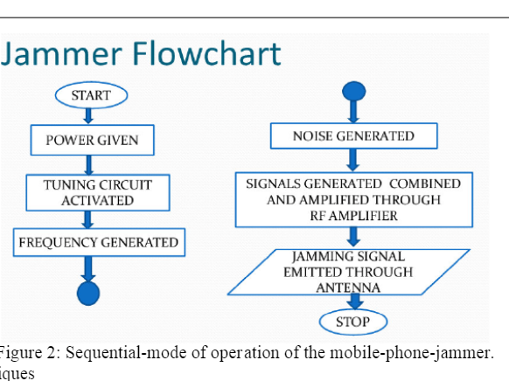

**WORKING**

RF [AMPLIFIER](https://electronicsforu.com/tag/amplifier) CIRCUIT COMPRISES OF THE TRANSISTOR Q1, CAPACITORS C4, C5 AND RESISTOR R1. THIS RF CIRCUIT AMPLIFIES THE SIGNAL GENERATED BY THE TUNED CIRCUIT. THE AMPLIFIED SIGNAL IS GIVEN TO THE ANTENNA THROUGH CAPACITOR C6. IT BLOCKS DC AND ALLOWS ONLY THE AC COMPONENT OF THE SIGNAL TO BE TRANSMITTED.

WHEN TRANSISTOR Q1 IS TURNED ON, THE TUNED CIRCUIT AT THE COLLECTOR TURNS ON. THE TUNED CIRCUIT CONSISTS OF CAPACITOR C1 AND INDUCTOR L1. THIS ACTS AS AN OSCILLATOR WITH ZERO RESISTANCE. IT PRODUCES VERY HIGH FREQUENCY WITH MINIMUM DAMPING.

WHEN THE CIRCUIT IS ON, VOLTAGE IS STORED IN THE CAPACITOR. ONCE THE CAPACITOR IS COMPLETELY CHARGED, IT ALLOWS CHARGE TO FLOW THROUGH THE INDUCTOR. WHEN CURRENT FLOWS THROUGH THE INDUCTOR, IT STORES MAGNETIC ENERGY CORRESPONDING TO THE VOLTAGE ACROSS THE CAPACITOR. AT A CERTAIN POINT, THE INDUCTOR REACHES ITS MAXIMUM AND THE CHARGE OR VOLTAGE ACROSS THE CAPACITOR TURNS TO ZERO.

NOW THE MAGNETIC CHARGE THROUGH THE INDUCTOR DECREASES AND THE CURRENT CHARGES THE CAPACITOR IN OPPOSITE OR REVERSE POLARITY. THE PROCESS REPEATS AND AFTER A WHILE, INDUCTOR CHARGES THE CAPACITOR AND BECOMES ZERO.

THIS PROCESS RUNS TILL INTERNAL RESISTANCE IS GENERATED AND THE OSCILLATIONS STOP. RF AMPLIFIER FEED IS GIVEN THROUGH CAPACITOR C5 TO THE COLLECTOR TERMINAL BEFORE C6. THE CAPACITORS C2 AND C3 GENERATE PULSES IN RANDOM FASHION (NOISE) AT THE FREQUENCY GENERATED BY THE TUNED CIRCUIT.

THE RF AMPLIFIER BOOSTS THE FREQUENCY GENERATED BY THE TUNED CIRCUIT. THE FREQUENCY GENERATED BY THE TUNED CIRCUIT AND THE NOISE SIGNAL GENERATED BY THE CAPACITORS C2 AND C3 IS COMBINED, AMPLIFIED AND TRANSMITTED.

**APPLICATION**

CELL PHONE JAMMING DEVICES WERE ORIGINALLY DEVELOPED FOR LAW ENFORCEMENT AND THE MILITARY TO INTERRUPT COMMUNICATIONS BY CRIMINALS AND TERRORISTS.

POLICE CAN CONTROL WHEN AND WHERE A CAPTOR CAN MAKE A PHONE CALL. POLICE CAN BLOCK PHONE CALLS DURING A DRUG RAID SO SUSPECTS CAN'T COMMUNICATE OUTSIDE THE AREA. CELL-PHONE JAMMERS CAN BE USED IN AREAS WHERE RADIO TRANSMISSIONS ARE DANGEROUS, (AREAS WITH A POTENTIALLY EXPLOSIVE ATMOSPHERE), SUCH AS CHEMICAL STORAGE FACILITIES OR GRAIN ELEVATORS. THE [TRJ-89 JAMMER](http://electronics.howstuffworks.com/framed.htm?parent=cell-phone-jammer.htm&url=http://www.antennasystems.com/cellular/trj-89_cellphonejammer.htm) FROM ANTENNA SYSTEM & SUPPLIES INC. CARRIES ITS OWN ELECTRICAL GENERATOR AND CAN BLOCK CELLULAR COMMUNICATIONS IN A 5-MILE (8-KM) RADIUS.

CORPORATIONS USE JAMMERS TO STOP CORPORATE ESPIONAGE BY BLOCKING VOICE TRANSMISSIONS AND PHOTO TRANSMISSIONS FROM CAMERA PHONES. ON THE MORE QUESTIONABLE END OF THE LEGITIMACY SPECTRUM, THERE ARE RUMORS THAT HOTEL CHAINS INSTALL JAMMERS TO BLOCK GUESTS' CELL-PHONE USAGE AND FORCE THEM TO USE IN-ROOM PHONES AT HIGH RATES.